SRM UNIVERSITY, KATTANKULATHUR

INTRODUCTION TO PROGRAMMING USING C

PROJECT REPORT ON

“BUS RESERVATION SYSTEM”

Submitted in partial fulfillment for the award of the degree in

BATCHELOR OF TECHNOLOGY

IN

BIOTECHNOLOGY

Submitted by:

. ANISHA SINGHA DEO (RA2111009010134)

. BABU VISHWAKARMA (RA2111009010135)

Under the guidance of

SIVA KUMAR SIR

PROJECT MENTOR

INTRODUCTION:

Our project is to computerize traveling company to manage data, so that all the transactions become fast and there should not be any error in transaction like calculation mistake, bill generation and other things. It replaces all the paper work. It keeps records of all bills also, giving to ensure 100% successful implementation of the computerized Bus reservation system.

ABSTRACT:

Bus reservation system is a project which uses c programming language and it was developed with the aim of creating a platform which will make people to book their tickets easily, holding bus details (like the bus number, destiny of the bus, prices of the bus tickets, no of seats available).

OBJECTIVES:

The objective was two-fold - to ensure that the Customers don’t have to leave the confines of their comfort to book a ticket, and to help them get a ticket when they need it the most. The internet was being voted as a medium people couldn’t do without. PC and net penetration has increased not only in urban areas, but also in rural India. Also, people were getting used to booking tickets for travel using IRCTC and private airline websites. So, why not buses?

Online system provides real time quotations, real time bus booking services for round trips, multiple payment channels, cost comparison, last minute booking, an in-house call center and even home delivery of tickets. Online system provides real time quotations, real time bus booking services for round trips, multiple payment channels, cost comparison, last minute booking, an in-house call center and even home delivery of tickets.

REQUIREMENTS:

**.** SOFTWARE REQUIREMENTS: **Operating system: window 11 home, online GDB compiler, Microsoft word.**

**.** HARDWARE REQUIREMENTS:  **PC with core i3, 512 GB RAM.**

**ALGORITHM:**

1) Taking a class named as a.

2) Declaring the variables and arrays as bus, arrival, depart, from, to, seat.

3) And in public of the class we are giving member functions as void install(); void allotment(); void empty(); void show(); void avail(); void position(int i);

4) And giving the maximum buses available are 10.

5) And now with respect to installing function we gave few options to enter in the run time which will gives to enter the bus details from back end of the system like bus no, Arrival time, Departure time, destiny of the buses.

6) And now with respect to allotment function we can allot seats for customer according to their preferable seat numbers.

7)And the empty function shows that the seats are empty in the bus.

8) And the show function shows that the how many seats available in the given bus. And which seats are already reserved in the bus.

OUTPUT:

Step 1: The first look of the output will be given as

Step 2: Second step is that we have to install the number of busses that we have to provide for customers and this is done by the backend system and in this function we have to give details of the bus like bus number, arrival time, departure time, from and to.

Step 3: We have to show the user how many busses are available in to travel that’s why we have to display the busses and their routes

Step 4: After checking the routes and the busses in the travels we have to show them that how many seats are empty in the given bus and the max number of seats that they can book.

Step 5: Now after all these conclusions we have to book the ticket for the passenger i.e; according to their opinion we have to book their seats according to the seat numbers they want and after booking we have to show them that what are the seats they reserved and bus details.

CODE:

#include<stdio.h>

#include<conio.h>

#include<stdlib.h>

#include<string.h>

typedef struct

{

char name[50];

int bus_num;

int num_of_seats;

}pd;

void reservation(void);

void viewdetails(void);

void printtickets(char name[],int,int,float);

float charge(int,int);

void specificbus(int);

int main()

{

system("cls");

printf("\t\t| BUS TICKET RESERVATION SYSTEM |\n");

printf("\t\t| By PARTNERS |\n");

printf("\t\t| AM.EN.U4EAC19030 |\n");

printf("\t\t------------------------------------------------------\n");

printf("\t\t---------------press any key to continue--------------\n");

printf("\t\t------------------------------------------------------\n");

getch();

system("cls");

int menu_choice,choice_return;

start:

system("cls");

printf("\n=================================\n");

printf(" BUS RESERVATION SYSTEM");

printf("\n=================================");

printf("\n1>> Reserve A Ticket");

printf("\n------------------------");

printf("\n2>> View All Available Bus");

printf("\n------------------------");

printf("\n3>> Exit");

printf("\n------------------------");

printf("\n\n-->");

scanf("%d",&menu_choice);

switch(menu_choice)

{

case 1:

reservation();

break;

case 2:

viewdetails();

printf("\n\nPress any key to go to Main Menu..");

getch();

break;

case 3:

return(0);

default:

printf("\nInvalid choice");

}

goto start;

return(0);

}

void viewdetails(void)

{

system("cls");

printf("\nBUS.No\tBUS Name\t\t\tDestinations\t\tfare\t\tTime\n");

printf("\n533101\tBus A\tKerala to karnataka\t\t Rs.5000\t\t9am");

printf("\n533102\tBus B\tKarnataka to Maharastra\t\t Rs.5000\t\t12pm");

printf("\n533103\tBus C\tKerala to Tamilnadu\t\t Rs.4500\t\t8am");

printf("\n533104\tBus D\tTamilnadu to Andhrapradesh\t\tRs.4500\t\t11am");

printf("\n533105\tBus E\tAndhrapradesh to telangana\t\tRs.5000\t\t7am");

}

void reservation(void)

{

char confirm;

int i=0;

float charges;

pd passdetails;

FILE *fp;

fp=fopen("seats_reserved.txt","a");

system("cls");

printf("\nEnter Your Name:> ");

fflush(stdin);

fgets(passdetails.name,sizeof(passdetails.name), stdin);

printf("\nEnter Number of seats:> ");

scanf("%d",&passdetails.num_of_seats);

printf("\n\n>>Press Enter To View Available Bus<< ");

getch();

system("cls");

viewdetails();

printf("\n\nEnter bus number:> ");

start1:

scanf("%d",&passdetails.bus_num);

if(passdetails.bus_num>=533101 && passdetails.bus_num<=533105)

{

charges=charge(passdetails.bus_num,passdetails.num_of_seats);

printtickets(passdetails.name,passdetails.num_of_seats,passdetails.bus_num,charges);

}

else

{

printf("\nInvalid bus Number! Enter again--> ");

goto start1;

}

printf("\n\nConfirm Ticket (y/n):>");

start:

scanf(" %c",&confirm);

if(confirm =='y')

{

fprintf(fp,"%s\t\t%d\t\t%d\t\t%.2f\n",passdetails.name,passdetails.num_of_seats,passdetails.bus_num,charges);

printf("==================");

printf("\n Reservation successful\n");

printf("==================");

printf("\nPress any key to go back to Main menu");

}

else

{

if(confirm=='n')

{

printf("\nReservation Not Done!\nPress any key to go back to Main menu!");

}

else

{

printf("\nInvalid choice entered! Enter again-----> ");

goto start;

}

}

fclose(fp);

getch();

}

float charge(int bus_num,int num_of_seats)

{

if (bus_num==533101)

{

return(5000.0*num_of_seats);

}

if (bus_num==533102)

{

return(5000.0*num_of_seats);

}

if (bus_num==533103)

{

return(4500.0*num_of_seats);

}

if (bus_num==533104)

{

return(4500.0*num_of_seats);

}

if (bus_num==533105)

{

return(5000.0*num_of_seats);

}

}

void printtickets(char name[],int num_of_seats,int bus_num,float charges)

{

system("cls");

printf("-------------------\n");

printf("\tTICKET\n");

printf("-------------------\n\n");

printf("Name:\t\t\t%s",name);

printf("\nNumber Of Seats:\t%d",num_of_seats);

printf("\nBus Number:\t\t%d",bus_num);

specificbus(bus_num);

printf("\nCharges:\t\t%.2f",charges);

}

void specificbus(int bus_num)

{

if (bus_num==533101)

{

printf("\nBus:\t\t\tBUS A");

printf("\nDestination:\t\tKerala to karnataka");

printf("\nDeparture:\t\t9am ");

}

if (bus_num==533102)

{

printf("\nBus:\t\t\tBUS B");

printf("\nDestination:\t\tKarnataka to Maharastra");

printf("\nDeparture:\t\t12pm");

}

if (bus_num==533103)

{

printf("\nBus:\t\t\tBUS C");

printf("\nDestination:\t\tKerala to Tamilnadu");

printf("\nDeparture:\t\t8am");

}

if (bus_num==533104)

{

printf("\nBus:\t\t\tBUS D");

printf("\nDestination:\t\tTamilnadu to Andhrapradesh");

printf("\nDeparture:\t\t11am ");

}

if (bus_num==533105)

{

printf("\nBus:\t\t\tBUS C");

printf("\nDestination:\t\tAndhrapradesh to telangana");

printf("\nDeparture:\t\t7am");

}

}

OUTPUT:

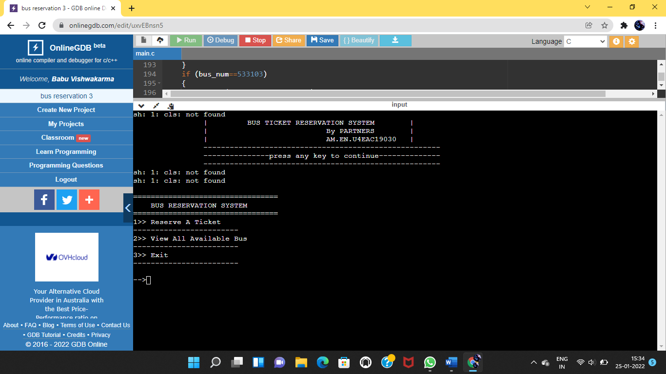

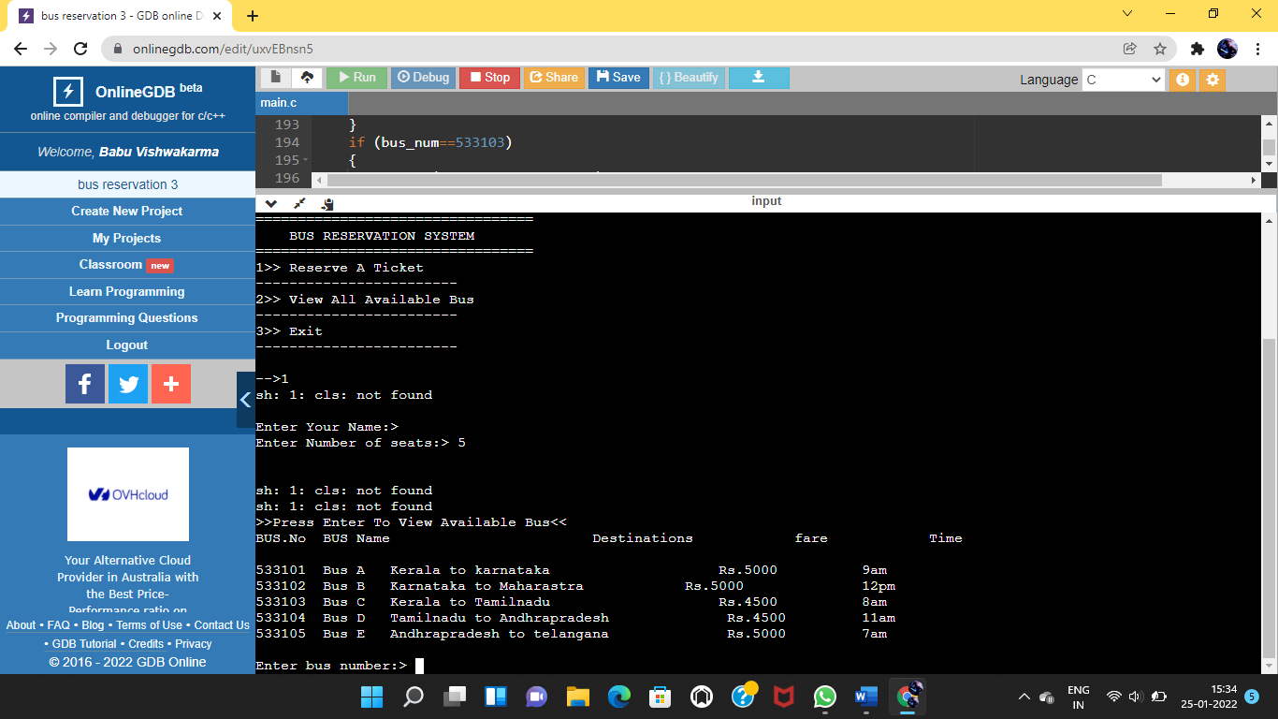

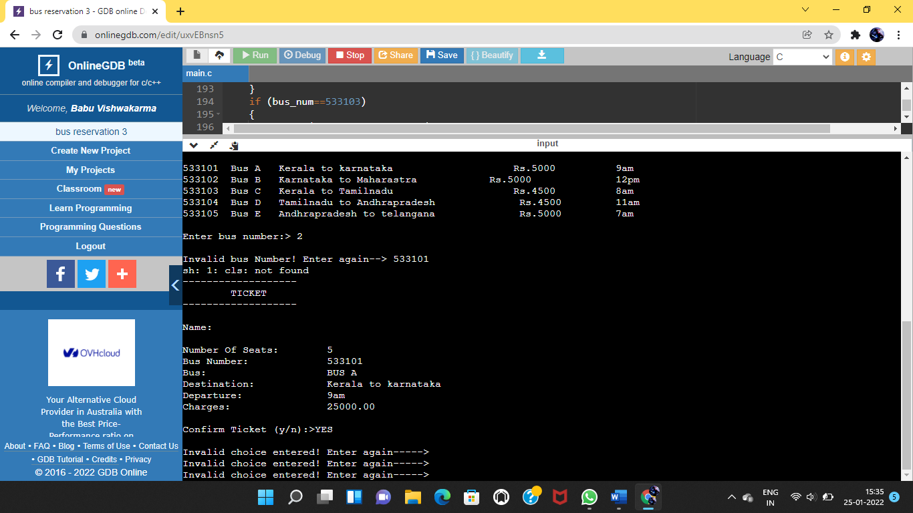

THANK YOU